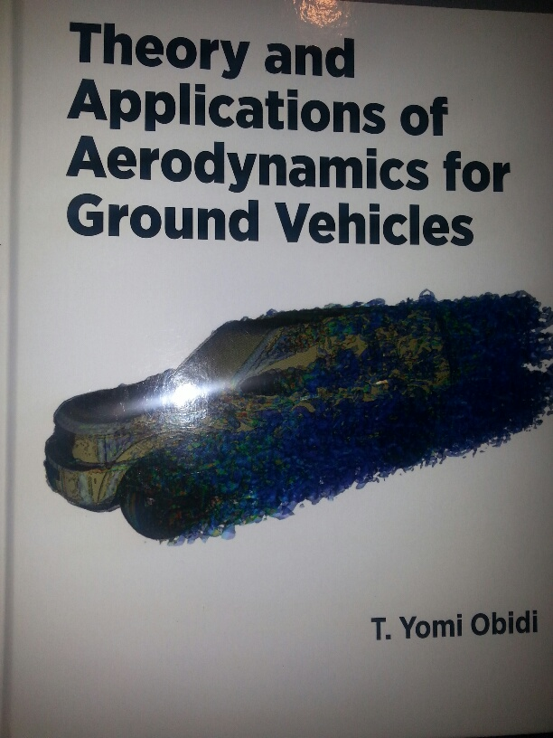

Interview with Dr. Yomi Obidi
Author of Theory and Applications of Aerodynamics for Ground Vehicles, by phone November 2014 Sussan Oladipo S: Sussan Y: Yomi

S: Thank you for giving me the opportunity to interview you in spite of your busy schedule.
Y: It is my pleasure and thank you for having me
S: What motivated you to write this book?
Y: As a child I had great interest in flight. The mystery of flight captivated me then. My father wanted me to become a medical doctor. The more I got into preparing to be a medical doctor, the more my interest in designing flying objects grew
II shared my ambition with my father and he asked me then to find out why the airplanes do not fall down but get suspended in the air when they fly. This quest became a project in my mind as something to do when I have an opportunity. Although I ended up writing a book about aerodynamics in ground vehicles, aerodynamics operates on both ground and air borne objects on the same principles.

S: Who is the intended audience for your book?
The book was written for senior undergraduate students, graduate students and practicing engineers. It covers the concept of drag and its origin in the reaction to air flow around the moving vehicles. It also explains the current engineering designs of vehicles and how the different designs attempt to overcome drag. An excellent design that reduces the effect of drag on moving vehicles will lead to greater efficient performance and better fuel consumption management. It will create a win-win situation for the owner, the economy and the environment.
I have devoted a significant attention of the publication on car-truck interactions in highways. This area according lacks the desired level of focus in the technical world of vehicle designs and highway safety. The last chapters of the book were devoted to applications with large body vehicles such as the train, and also to fast moving sport cars and racecars.
S: What excites you?
I am excited about the opportunity to share my life ambition with others through this book and to continue to build students enthusiasm for real world application of science.
S: What is your background?
I have a PhD in mechanical engineering and have worked in many engineering companies. I was given a plane by Nigerian Airways to work on as a redesign project and was able to accomplish the task with my team. I have worked in engine design companies and have always been driven by the slogan-“this is physics not magic” as I apply the theory of physics in the engineering field. I belong to the Society of Aeronautic Engineers.

S: What is your world of wonder?
I am still fascinated by aerodynamics and how it relates to passenger comfort in vehicles. My job as an engineer would be to fix it. S: How do you see the value in your book for learners?
Sharing the concept of aerodynamics in my book is of immense value to readers because vehicles that improved aerodynamics have better fuel efficiency, improved performance and increased passenger comfort
S: How do you apply these principles to other areas of learning?
Passenger comfort with respect to air movement in the vehicle is part of the design. Poor air movement in the vehicle can cause discomfort. Under highway motion, a car can be sucked under the wheel of a fast moving truck. This phenomenon has led to a proposal to the department of transportation.
I will like to see the application of real world sciences in all classrooms across the nation. Students still have curiosity that need to be evoked by science teachers. There are still a lot of hidden concepts and inventions in science that need to be explored by our young scientists.
S: What technology applications do you use or have you used in doing your work as an author and scientist?
Y: Technology is an indispensable tool in the application and teaching of sciences. I have used it various technology tools in my work and publications. Example, I have documented podcasts of my work with the Society of Aeronautical Engineers. I have made a “Model of the Human Eye” using technology. In addition, I have a video on each chapter of my book. The videos are designed in such a way that a layman can connect to it. It also adds the needed visuals and aesthetics, without which science has been seen to be dry and rather abstract.
S: What are your thoughts about increasing student opportunities for science and engineering within our K-12 public school system?
Y: My suggestion is to catch them when they are still young. There is an environment of freedom that destroys the academic system. Give them a lot of load when they are still little. We are expecting more from those who make decisions.

S: Are you looking forward to writing more books?
Y: I have interest in Aeronautics and currently working with another author. I have a presentation with a publishing company and this project is in the works.
S: Thank you for your time for this interview Dr. Obidi.

BOOK REVIEW: Theory and Applications of Aerodynamics for Ground Vehicles by Dr. T. Y. Obidi (2014, SAE International)
Aerodynamics is an important subject that describes the interactions between moving objects and their environment. The gases and air in the environment and their effects on motions have been a concern for engineers and scientists as they attempt to improve performance efficiency of various vehicular objects. Examples of formal definitions of aerodynamics include the following:
“Aerodynamics is the way air moves around things. The rules of aerodynamics explain how an airplane is able to fly. Anything that moves through air reacts to aerodynamics. A rocket blasting off the launch pad and a kite in the sky react to aerodynamics. Aerodynamics even acts on cars, since air flows around cars”. (Www.nasa.gov)
“Aerodynamics is the study of the properties of moving air and the interaction between the air and solid bodies moving through it”. (www.oxforddictionaries.com)
“Aerodynamics is the branch of mechanics that deals with the motion of air and other gases and with the effects of such motion on bodies in the medium”. (Ask.com)
The textbook titled “Theory and Applications of Aerodynamics for Ground Vehicles” written by Dr. T. Y. Obidi was published in 2014 by the Society of Automotive Engineers (SAE International). It seeks to explain the fundamentals of aerodynamics and its applications to ground vehicles like cars and trucks to students while they are still in school. It also offers guidance to them from their current levels to professional engineers’ level. The author therefore covers additional material than most traditional textbooks in this field. One of such fields is what the author describes as car-truck interactions. The discussion of the car-truck interactions explains the effects of vehicles overtaking each other on the highways. The overtaking could be between car-car, car-truck and truck-truck. The author believes a better understanding of these interactions will improve safety on our highways where significant numbers of deaths are recorded annually. These accidents are as a result of one vehicle overtaking another.
The textbook has very good readability level that an average reader with some background in engineering and science will be able to comprehend. The diagrams and pictures are also very clear and help explain the concept at a higher level of detail that connects the reader to actual real life situations. Several pages contain diagrams and pictures of ground vehicles like motorcycles, farm machineries, in-plant carts, cars, trucks, trains, tricycles and human beings as we walk, jog or run.
The book was written for senior undergraduate students, graduate students and practicing engineers’ covers the concept of drag and its origin in the reaction to air flow around the moving vehicles. It also explains the current engineering designs of vehicles and how the different designs attempt to overcome drag. An excellent design that reduces the effect of drag on moving vehicles will lead to greater efficient performance and better fuel consumption management. It will create a win-win situation for the owner, the economy and the environment.
The book included the use of numerical solutions based on computational models, a kind of “computational aerodynamics” applicable to ground vehicles. The simplification of modeling as a way to describe the advantages and disadvantages of vehicle designs may have substantial impact on the younger generation even at the high school and middle school level as most of the students are interested in devices like computers and other mobile devices. A connection with this level of students using modeling may stimulate and steer them towards careers in STEM fields.
The author devoted a significant attention of the publication on his work on car-truck interactions on the highways. This area according to the author lacks the desired level of focus in the technical world of vehicle designs and highway safety. The last chapters of the book were devoted to applications with large body vehicles such as the train, and also to fast moving sport cars and racecars.
The author, Dr. T. Y. Obidi is currently the director of Research and Development at Tamayi Kristi, LLC. He has experiences that covers over thirty-five years in industries and academics. He held several positions at Ryerson Polytechnic Institute, State University College at Buffalo, University of Ibadan and Embry-Riddle Aeronautical University. He was a cooling system engineer at International Truck and Engine Corporation, and at DaimlerChrysler. He was an assistant aerodynamic consultant through the University of Florida. He was a director of the wind tunnel laboratory and also serves as an adjunct Mathematics and Science Faculty at the City Colleges of Chicago.

